# How to create an account in Git Hub

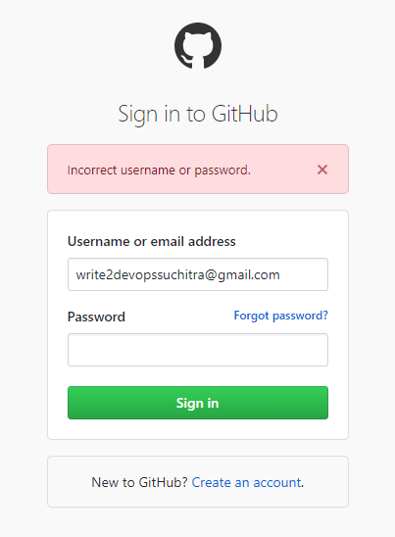

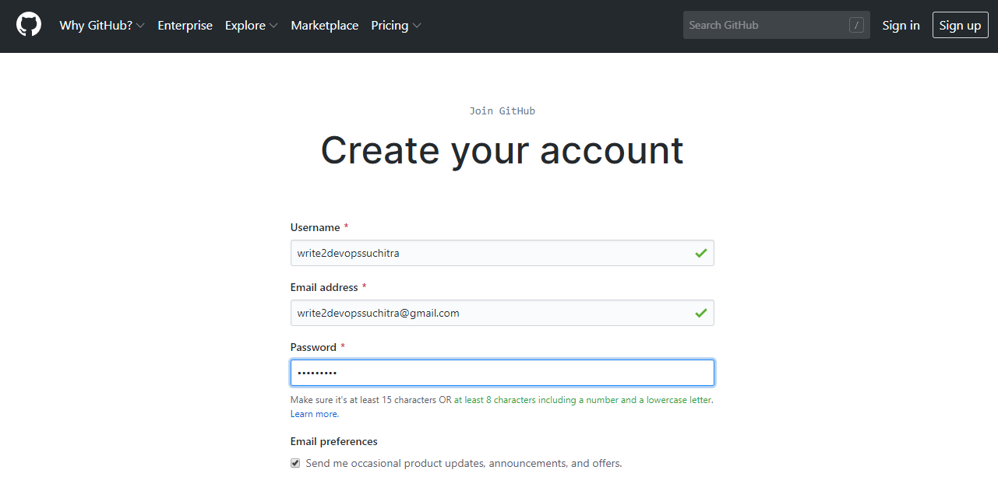

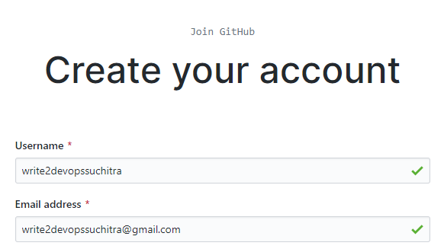

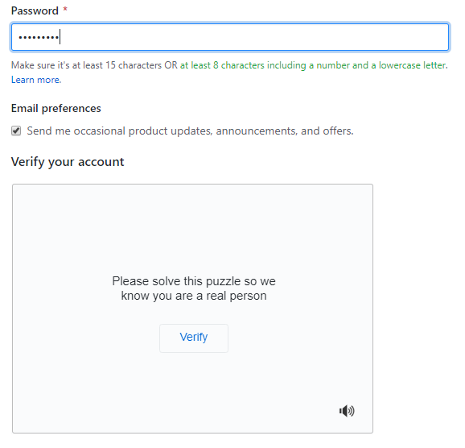

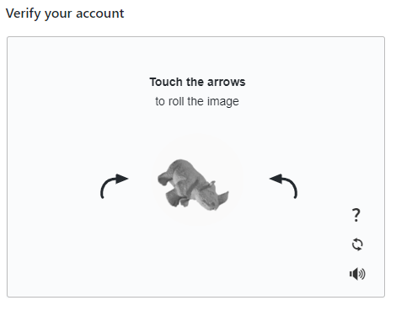

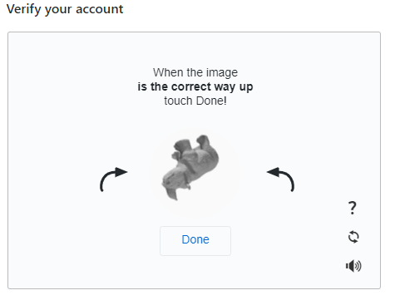

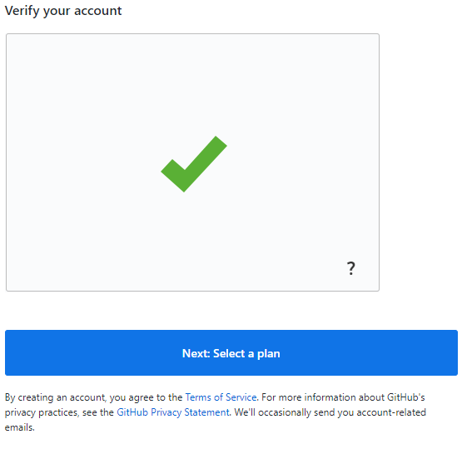

Note: Password is weak and can easily be guessed.

# **Creating a strong password**

Secure your GitHub account with a strong and unique password using a password manager.

You must choose or generate a password for your GitHub account that is:

* Eight characters long, if it includes a number and a lowercase letter, or
* 16 characters long with any combination of characters

To keep your account secure, we recommend you follow these best practices:

* Use a password manager, such as [LastPass](https://lastpass.com/) or [1Password](https://1password.com/), to generate a password more than 16 characters.
* Generate a unique password for GitHub. If you use your GitHub password elsewhere and that service is compromised, then attackers or other malicious actors could use that information to access your GitHub account.
* Configure two-factor authentication for your personal account. For more information, see "[About two-factor authentication](https://help.github.com/en/articles/about-two-factor-authentication)."
* Never share your password, even with a potential collaborator. Each person should use their own personal account on GitHub. For more information on ways to collaborate, see: "[Inviting collaborators to a personal repository](https://help.github.com/en/articles/inviting-collaborators-to-a-personal-repository)," "[About collaborative development models](https://help.github.com/en/articles/about-collaborative-development-models)," or "[Collaborating with groups in organizations](https://help.github.com/en/articles/collaborating-with-groups-in-organizations)."

When you type a password to sign in, create an account, or change your password, GitHub will check if the password you entered is considered weak according to datasets like HaveIBeenPwned. The password may be identified as weak even if you have never used that password before.

GitHub only inspects the password at the time you type it, and never stores the password you entered in plaintext. For more information, see [HaveIBeenPwned](https://haveibeenpwned.com/).

### [**Further reading**](https://help.github.com/en/github/authenticating-to-github/creating-a-strong-password#further-reading)

* "[Caching your GitHub password in Git](https://help.github.com/en/articles/caching-your-github-password-in-git)"
* "[Keeping your account and data secure](https://help.github.com/en/articles/keeping-your-account-and-data-secure)"

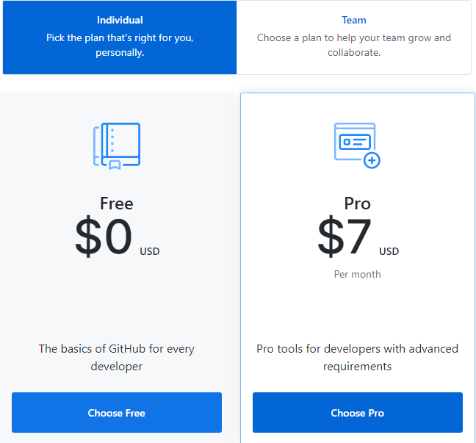

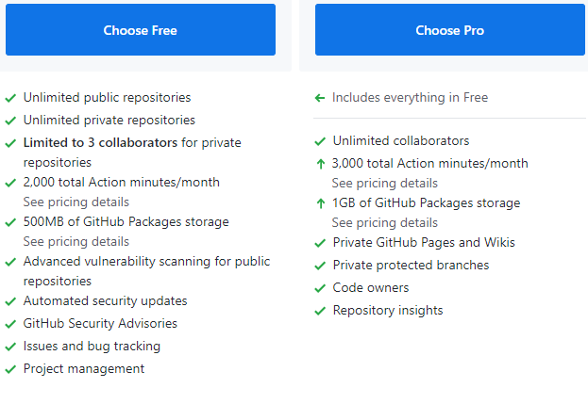

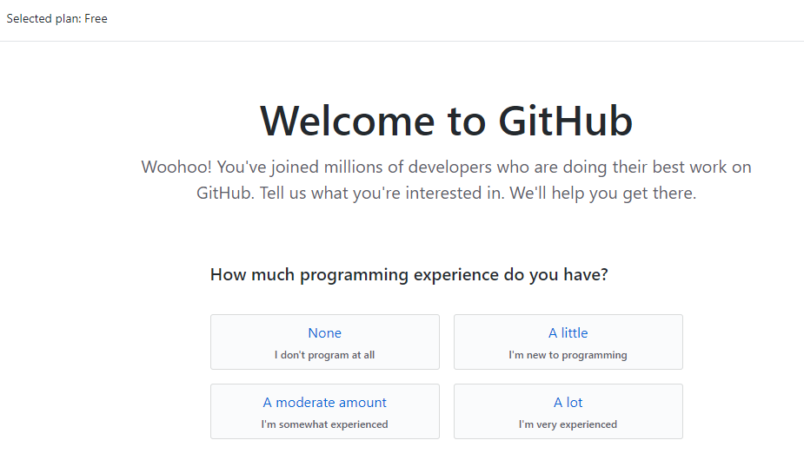

There are several questions that you might try to answer related to programming experience, usage of github and so on. This will help you to connect to communities and projects that you will fit in.

